## **What is Java?**

Java is a **programming language** and a **platform**. Java is a high level, robust, object-oriented and secure programming language.

Java was developed by *Sun Microsystems* (which is now the subsidiary of Oracle) in the year 1995. *James Gosling* is known as the father of Java. Before Java, its name was *Oak*. Since Oak was already a registered company, so James Gosling and his team changed the name from Oak to Java.

**Platform**: Any hardware or software environment in which a program runs, is known as a platform. Since Java has a runtime environment (JRE) and API, it is called a platform.10s

## **Java Example**

Let's have a quick look at Java programming example. A detailed description of Hello Java example is available in next page.

**Simple.java**

**class** Simple{

**public** **static** **void** main(String args[]){

     System.out.println("Hello Java");

    }

}

## **Application**

According to Sun, 3 billion devices run Java. There are many devices where Java is currently used. Some of them are as follows:

1. Desktop Applications such as acrobat reader, media player, antivirus, etc.
2. Web Applications such as irctc.co.in, javatpoint.com, etc.
3. Enterprise Applications such as banking applications.
4. Mobile
5. Embedded System
6. Smart Card
7. Robotics
8. Games, etc.

## **Types of Java Applications**

There are mainly 4 types of applications that can be created using Java programming:

#### **1) Standalone Application**

Standalone applications are also known as desktop applications or window-based applications. These are traditional software that we need to install on every machine. Examples of standalone application are Media player, antivirus, etc. AWT and Swing are used in Java for creating standalone applications.

#### **2) Web Application**

An application that runs on the server side and creates a dynamic page is called a web application. Currently, Servlet , JSP, Struts, Spring, Hibernate, JSF, etc. technologies are used for creating web applications in Java.

#### **3) Enterprise Application**

An application that is distributed in nature, such as banking applications, etc. is called an enterprise application. It has advantages like high-level security, load balancing, and clustering. In Java, EJB is used for creating enterprise applications.

#### **4) Mobile Application**

An application which is created for mobile devices is called a mobile application. Currently, Android and Java ME are used for creating mobile applications.

## **Java Platforms / Editions**

There are 4 platforms or editions of Java:

#### **1) Java SE (Java Standard Edition)**

It is a Java programming platform. It includes Java programming APIs such as java.lang, java.io, java.net, java.util, java.sql, java.math etc. It includes core topics like OOPs, String, Regex, Exception, Inner classes, Multithreading, I/O Stream, Networking, AWT, Swing, Reflection, Collection, etc.

#### **2) Java EE (Java Enterprise Edition)**

It is an enterprise platform that is mainly used to develop web and enterprise applications. It is built on top of the Java SE platform. It includes topics like Servlet, JSP, Web Services, EJB, JPA, etc.

#### **3) Java ME (Java Micro Edition)**

It is a micro platform that is dedicated to mobile applications.

#### **4) JavaFX**

It is used to develop rich internet applications. It uses a lightweight user interface API.

# Difference between JDK, JRE, and JVM

### **JVM**

JVM (Java Virtual Machine) is an abstract machine. It is called a virtual machine because it doesn't physically exist. It is a specification that provides a runtime environment in which Java bytecode can be executed. It can also run those programs which are written in other languages and compiled to Java bytecode.

JVMs are available for many hardware and software platforms. JVM, JRE, and JDK are platform dependent because the configuration of each [OS](https://www.javatpoint.com/os-tutorial) is different from each other. However, Java is platform independent. There are three notions of the JVM: *specification*, *implementation*, and *instance*.

The JVM performs the following main tasks:

* Loads code
* Verifies code
* Executes code
* Provides runtime environment

### **JRE**

JRE is an acronym for Java Runtime Environment. It is also written as Java RTE. The Java Runtime Environment is a set of software tools which are used for developing Java applications. It is used to provide the runtime environment. It is the implementation of JVM. It physically exists. It contains a set of libraries + other files that JVM uses at runtime.

The implementation of JVM is also actively released by other companies besides Sun Micro Systems.

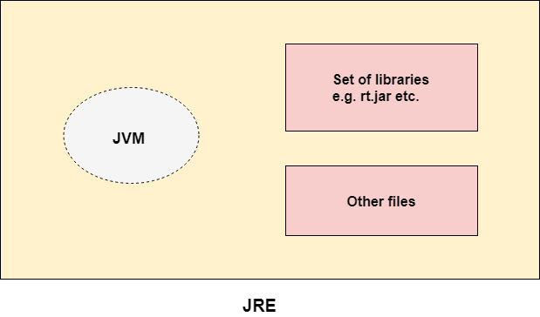

### **JDK**

JDK is an acronym for Java Development Kit. The Java Development Kit (JDK) is a software development environment which is used to develop Java applications and applets. It physically exists. It contains JRE + development tools.

JDK is an implementation of any one of the below given Java Platforms released by Oracle Corporation:

* Standard Edition Java Platform
* Enterprise Edition Java Platform
* Micro Edition Java Platform

The JDK contains a private Java Virtual Machine (JVM) and a few other resources such as an interpreter/loader (java), a compiler (javac), an archiver (jar), a documentation generator (Javadoc), etc. to complete the development of a Java Application.

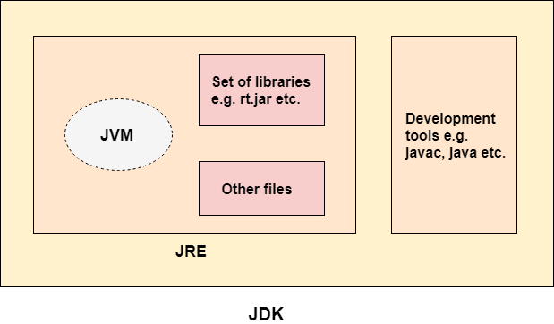

# JVM (Java Virtual Machine) Architecture

JVM (Java Virtual Machine) is an abstract machine. It is a specification that provides runtime environment in which java bytecode can be executed.

JVMs are available for many hardware and software platforms (i.e. JVM is platform dependent).

### **What is JVM**

1. **A specification** where working of Java Virtual Machine is specified. But implementation provider is independent to choose the algorithm. Its implementation has been provided by Oracle and other companies.
2. **An implementation** Its implementation is known as JRE (Java Runtime Environment).
3. **Runtime Instance** Whenever you write java command on the command prompt to run the java class, an instance of JVM is created.

### **What it does**

The JVM performs following operation:

* Loads code
* Verifies code
* Executes code
* Provides runtime environment

JVM provides definitions for the:

* Memory area
* Class file format
* Register set
* Garbage-collected heap
* Fatal error reporting etc.

## **JVM Architecture**

Let's understand the internal architecture of JVM. It contains classloader, memory area, execution engine etc.

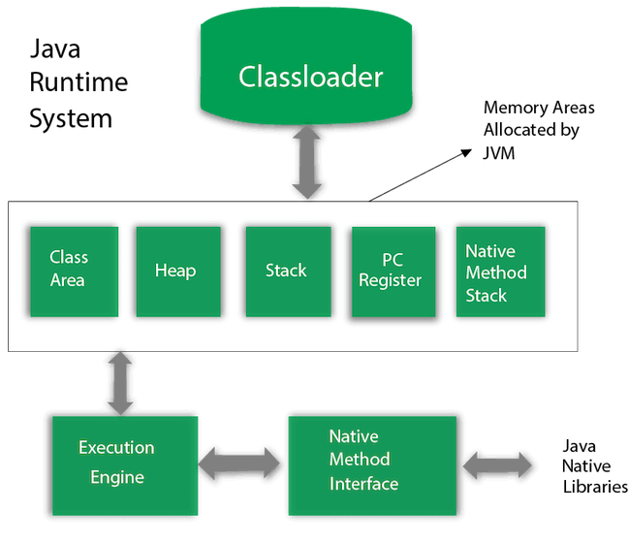

### **1) Classloader**

Classloader is a subsystem of JVM which is used to load class files. Whenever we run the java program, it is loaded first by the classloader. There are three built-in classloaders in Java.

1. **Bootstrap ClassLoader**: This is the first classloader which is the super class of Extension classloader. It loads the *rt.jar* file which contains all class files of Java Standard Edition like java.lang package classes, java.net package classes, java.util package classes, java.io package classes, java.sql package classes etc.
2. **Extension ClassLoader**: This is the child classloader of Bootstrap and parent classloader of System classloader. It loades the jar files located inside *$JAVA_HOME/jre/lib/ext* directory.
3. **System/Application ClassLoader**: This is the child classloader of Extension classloader. It loads the classfiles from classpath. By default, classpath is set to current directory. You can change the classpath using "-cp" or "-classpath" switch. It is also known as Application classloader.

//Let's see an example to print the classloader name

**public** **class** ClassLoaderExample

{

**public** **static** **void** main(String[] args)

    {

        // Let's print the classloader name of current class.

        //Application/System classloader will load this class

        Class c=ClassLoaderExample.**class**;

        System.out.println(c.getClassLoader());

        //If we print the classloader name of String, it will print null because it is an

        //in-built class which is found in rt.jar, so it is loaded by Bootstrap classloader

        System.out.println(String.**class**.getClassLoader());

    }

}

Output:

sun.misc.Launcher$AppClassLoader@4e0e2f2a

null

These are the internal classloaders provided by Java. If you want to create your own classloader, you need to extend the ClassLoader class.

### **2) Class(Method) Area**

Class(Method) Area stores per-class structures such as the runtime constant pool, field and method data, the code for methods.

### **3) Heap**

It is the runtime data area in which objects are allocated.

### **4) Stack**

Java Stack stores frames. It holds local variables and partial results, and plays a part in method invocation and return.

Each thread has a private JVM stack, created at the same time as thread.

A new frame is created each time a method is invoked. A frame is destroyed when its method invocation completes.

### **5) Program Counter Register**

PC (program counter) register contains the address of the Java virtual machine instruction currently being executed.

### **6) Native Method Stack**

It contains all the native methods used in the application.

### **7) Execution Engine**

It contains:

1. **A virtual processor**
2. **Interpreter:** Read bytecode stream then execute the instructions.
3. **Just-In-Time(JIT) compiler:** It is used to improve the performance. JIT compiles parts of the byte code that have similar functionality at the same time, and hence reduces the amount of time needed for compilation. Here, the term "compiler" refers to a translator from the instruction set of a Java virtual machine (JVM) to the instruction set of a specific CPU.

### **8) Java Native Interface**

Java Native Interface (JNI) is a framework which provides an interface to communicate with another application written in another language like C, C++, Assembly etc. Java uses JNI framework to send output to the Console or interact with OS libraries.

# Java OOPs Concepts

In this page, we will learn about the basics of OOPs. Object-Oriented Programming is a paradigm that provides many concepts, such as **inheritance**, **data binding**, **polymorphism**, etc.

**Simula** is considered the first object-oriented programming language. The programming paradigm where everything is represented as an object is known as a truly object-oriented programming language.

**Smalltalk** is considered the first truly object-oriented programming language.

The popular object-oriented languages are Java, C#, PHP, Python, C++, etc.kip 10sPlayoForward Skip 10s

The main aim of object-oriented programming is to implement real-world entities, for example, object, classes, abstraction, inheritance, polymorphism, etc.

## **OOPs (Object-Oriented Programming System)**

**Object** means a real-world entity such as a pen, chair, table, computer, watch, etc. **Object-Oriented Programming** is a methodology or paradigm to design a program using classes and objects. It simplifies software development and maintenance by providing some concepts:

* Object
* Class
* Inheritance
* Polymorphism
* Abstraction
* Encapsulation

Apart from these concepts, there are some other terms which are used in Object-Oriented design:

* Coupling
* Cohesion
* Association
* Aggregation
* Composition

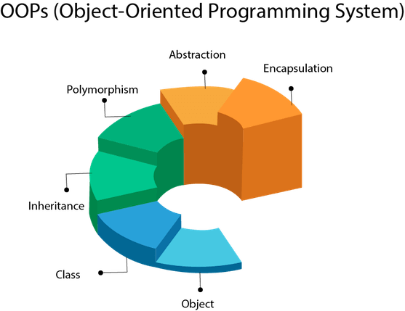

## **Object**

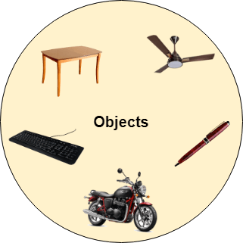

Any entity that has state and behavior is known as an object. For example, a chair, pen, table, keyboard, bike, etc. It can be physical or logical.

An Object can be defined as an instance of a class. An object contains an address and takes up some space in memory. Objects can communicate without knowing the details of each other's data or code. The only necessary thing is the type of message accepted and the type of response returned by the objects.

**Example:** A dog is an object because it has states like color, name, breed, etc. as well as behaviors like wagging the tail, barking, eating, etc.

## **Class**

*Collection of objects* is called class. It is a logical entity.

A class can also be defined as a blueprint from which you can create an individual object. Class doesn't consume any space.

### **Inheritance**

*Inheritance is an object-oriented programming concept in which one class acquires the properties and behavior of another class. It represents a parent-child relationship between two classes. This parent-child relationship is also known as an IS-A relationship.*

*When one object acquires all the properties and behaviors of a parent object*, it is known as inheritance. It provides code reusability. It is used to achieve runtime polymorphism.

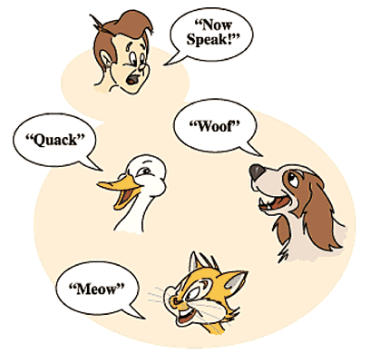

### **Polymorphism**

*The word “Polymorphism” derives from two words i.e.* ***“Poly”*** *which means many and “****morphs****” meaning forms. Thus polymorphism means many forms. In a programming language, we can say that an object can take many forms, and hence the object is polymorphic.*

*Polymorphism in Java can be achieved in two ways i.e., method overloading and method overriding.*

*Polymorphism in Java is mainly divided into two types.*

* *Compile-time polymorphism*
* *Runtime polymorphism*

*Compile-time polymorphism can be achieved by method overloading, and Runtime polymorphism can be achieved by method overriding. In the further article, we will be discussing all the topics related to polymorphism in Java in more detail.*

#### **Abstraction**

Abstraction in Java refers to hiding the implementation details of a code and exposing only the necessary information to the user. It provides the ability to simplify complex systems by ignoring irrelevant details and reducing complexity.

*So hiding internal details of implementation and showing the functionality* of the methods is known as abstraction. For example phone call, we don't know the internal processing.

In Java, we use abstract class and interface to achieve abstraction.

### **Encapsulation**

Encapsulation is a way to restrict the direct access to some components of an object, so users cannot access state values for all of the variables of a particular object. Encapsulation can be used to hide both data members and data functions or methods associated with an instantiated class or object.

A java class is the example of encapsulation. Java bean is the fully encapsulated class because all the data members are private here.

### **Coupling**

Coupling refers to the knowledge or information or dependency of another class. It arises when classes are aware of each other. If a class has the details information of another class, there is strong coupling. In Java, we use private, protected, and public modifiers to display the visibility level of a class, method, and field. You can use interfaces for the weaker coupling because there is no concrete implementation.

### **Cohesion**

Cohesion refers to the level of a component which performs a single well-defined task. A single well-defined task is done by a highly cohesive method. The weakly cohesive method will split the task into separate parts. The java.io package is a highly cohesive package because it has I/O related classes and interface. However, the java.util package is a weakly cohesive package because it has unrelated classes and interfaces.

### **Association**

Association represents the relationship between the objects. Here, one object can be associated with one object or many objects. There can be four types of association between the objects:

* One to One
* One to Many
* Many to One, and
* Many to Many

Let's understand the relationship with real-time examples. For example, One country can have one prime minister (one to one), and a prime minister can have many ministers (one to many). Also, many MP's can have one prime minister (many to one), and many ministers can have many departments (many to many).

Association can be undirectional or bidirectional.

### **Aggregation**

Aggregation is a way to achieve Association. Aggregation represents the relationship where one object contains other objects as a part of its state. It represents the weak relationship between objects. It is also termed as a *has-a* relationship in Java. Like, inheritance represents the *is-a* relationship. It is another way to reuse objects.

### **Composition**

The composition is also a way to achieve Association. The composition represents the relationship where one object contains other objects as a part of its state. There is a strong relationship between the containing object and the dependent object. It is the state where containing objects do not have an independent existence. If you delete the parent object, all the child objects will be deleted automatically.

## **Advantage of OOPs over Procedure-oriented programming language**

1) OOPs makes development and maintenance easier, whereas, in a procedure-oriented programming language, it is not easy to manage if code grows as project size increases.

2) OOPs provides data hiding, whereas, in a procedure-oriented programming language, global data can be accessed from anywhere.

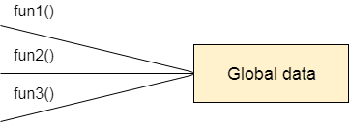

Figure: Data Representation in Procedure-Oriented Programming

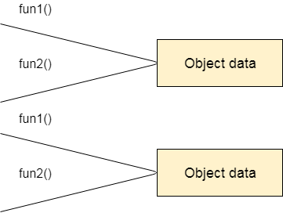

Figure: Data Representation in Object-Oriented Programming

3) OOPs provides the ability to simulate real-world event much more effectively. We can provide the solution of real word problem if we are using the Object-Oriented Programming language.

## **What is the difference between an object-oriented programming language and object-based programming language?**

Object-based programming language follows all the features of OOPs except Inheritance. JavaScript and VBScript are examples of object-based programming languages.